DuaDeep-SeqAffinity: Dual-Stream Deep Learning Framework for Sequence-Only Antigen-Antibody Affinity Prediction

Aicha Boutorh ∗
National School of Artificial Intelligence (ENSIA) Algiers, 16000, Algeria aicha.boutorh@ensia.edu.dz

Soumia Bouyahiaoui
National School of Artificial Intelligence (ENSIA) Algiers, 16000, Algeria soumia.bouyahiaoui@ensia.edu.dz

Sara Belhadj
National School of Artificial Intelligence (ENSIA) Algiers, 16000, Algeria sara.belhadj@ensia.edu.dz

Nour El Yakine Guendouz
National School of Artificial Intelligence (ENSIA)
Algiers, 16000, Algeria
nour-el-yakine.guendouz@ensia.edu.dz

arXiv:2512.22007v1 [cs.LG] 26 Dec 2025

Manel Kara Laouar
National School of Artificial Intelligence (ENSIA) Algiers, 16000, Algeria manel.karalaouar@ensia.edu.dz

December 29, 2025

Abstract

Predicting the binding affinity between antigens and antibodies is fundamental to drug discovery and vaccine development. Traditional computational approaches often rely on experimentally determined 3D structures, which are scarce and computationally expensive to obtain. This paper introduces DuaDeep-SeqAffinity, a novel sequence-only deep learning framework that predicts affinity scores solely from their amino acid sequences using a dual-stream hybrid architecture. Our approach leverages pre-trained ESM-2 protein language model embeddings, combining 1D Convolutional Neural Networks (CNNs) for local motif detection with Transformer encoders for global contextual representation. A subsequent fusion module integrates these multi-faceted features, which are then passed to a fully connected network for final score regression. Experimental results demonstrate that DuaDeep-SeqAffinity significantly outperforms individual architectural components and existing state-of-the-art (SOTA) methods. DuaDeep achieved a superior Pearson correlation of 0.688, an R² of 0.460, and a Root Mean Square Error (RMSE) of 0.737, surpassing single-branch variants ESM-CNN and ESM-Transformer. Notably, the model achieved an Area Under the Curve (AUC) of 0.890, outperforming sequence-only benchmarks and even surpassing structure-sequence hybrid models. These findings prove that high-fidelity sequence embeddings can capture essential binding patterns typically reserved for structural modeling. By eliminating the reliance on 3D structures, DuaDeep-SeqAffinity provides a highly scalable and efficient solution for high-throughput screening of vast sequence libraries, significantly accelerating the therapeutic discovery pipeline.

Keywords Dual-Stream Deep Learning · Transformer Encoders · 1D Convolutional Neural Networks · Protein Language Models (ESM-2) · Antigen-Antibody Interaction · Affinity Prediction · Amino Acid Sequence-only Modeling

∗Corresponding author

Introduction

The specific, high-affinity interaction between antigens and antibodies underpins the adaptive immune response and represents a primary target for therapeutic intervention. Precise prediction of binding strength, often characterized by docking scores or binding affinity, is indispensable for the identification of high-potency therapeutic leads, the rational design of vaccines, and the engineering of sensitive diagnostic platforms [1, 2]. As therapeutic discovery shifts toward high-throughput digital screening, the development of robust computational tools capable of predicting these binding dynamics with high precision has become a critical necessity in accelerating the drug development pipeline.

Current state-of-the-art computational methods for predicting protein–protein interactions (PPIs), including antigen–antibody complexes, predominantly rely on molecular docking simulations and physics-based energy scoring. These methodologies necessitate precise 3D structural information for both interacting partners to model the spatial complementarity and physicochemical forces at the binding interface [3, 4]. However, the availability of high-resolution experimental structures, resolved via X-ray crystallography or Cryo-Electron Microscopy (Cryo-EM), remains a significant bottleneck due to the time-consuming and resource-intensive nature of these techniques [5].

While computational structure prediction breakthroughs like AlphaFold2 and AlphaFold3 have made remarkable strides in general protein modeling, they still face substantial challenges in the antibody-antigen domain. Recent benchmarks indicate that even the most advanced multimer models exhibit a failure rate of approximately 60% in accurately docking antibody-antigen complexes when orthologous sequences are limited [6, 7]. This is primarily due to the hypervariable nature of the Complementarity-Determining Regions (CDRs), particularly the CDR-H3 loop, which often undergoes significant conformational changes upon binding, a dynamic process that static structure-based methods fail to capture effectively [8, 9].

The inherent information within an amino acid sequence dictates its folded structure and, by extension, its interaction properties. Recent breakthroughs in Protein Language Models (PLMs), such as ESM-2, demonstrate an exceptional ability to learn these complex relationships from vast unlabeled protein sequence datasets. By treating protein sequences as a "language," these models provide rich, contextualized embeddings that implicitly encode the biophysical and evolutionary signatures necessary for binding [10, 11].

Leveraging these embeddings presents an unprecedented opportunity to move beyond explicit structural modeling and directly infer interaction characteristics from sequences. Recent studies have begun exploring sequence-only regressive frameworks to predict binding affinity changes, demonstrating that PLM-driven models can achieve competitive performance with structural methods while being orders of magnitude faster [12, 13]. This sequence-only paradigm is particularly vital for screening novel antibody repertoires where structural templates are absent, providing a scalable and efficient solution for high-throughput therapeutic discovery.

To address these challenges, we present DuaDeep-SeqAffinity, a novel deep learning framework engineered to predict antigen–antibody affinity scores directly from primary amino acid sequences. The core innovation of our approach lies in the synergistic integration of high-capacity ESM-2 embeddings with a specialized dual-stream Transformer–CNN hybrid architecture. Our architecture is specifically designed to perform multiscale feature extraction. By processing sequences through parallel streams, the model simultaneously captures long-range global dependencies, critical for understanding overall protein fold and stability, and fine-grained local motifs that define the physicochemical environment of the binding interface.

The utility of the DuaDeep-SeqAffinity framework is profound. By operating independently of tertiary structural data, it provides a high-throughput, scalable, and cost-effective alternative to traditional docking simulations. This sequence-only paradigm effectively circumvents the "structural bottleneck," enabling the rapid screening of expansive antibody repertoires and the acceleration of rational vaccine design. Furthermore, by drastically reducing the computational overhead associated with affinity maturation and lead optimization, this model promises to expedite the pre-clinical phases of therapeutic development, offering a robust tool for personalized immunotherapy and rapid-response pandemic preparedness.

The remainder of this paper is structured as follows: Section 2 provides a comprehensive review of related literature and the theoretical background of protein language models. Section 3 details the proposed methodology, including the

dual-stream architecture and fusion strategies. Section 4 presents the experimental results, benchmarking our model against current state-of-the-art methods and discussing the implications of our findings. Finally, Section 5 concludes the paper with a summary of contributions and directions for future research.

Background and Related Works

Antibody–Antigen Interaction
The antibody-mediated immune response is a critical component of the adaptive immune system, responsible for the highly specific recognition and neutralization of foreign substances, including viruses, bacteria, and toxins. Antibodies, or immunoglobulins (Ig), are Y-shaped glycoproteins synthesized by B lymphocytes [14, 15, 16]. Each antibody identifies a specific molecular region on an antigen, known as an epitope, via its paratope, the physical binding site located at the tips of the antibody’s variable regions [17]. The architecture of these variable regions is defined by six hypervariable loops termed complementarity-determining regions (CDRs), with three situated on the heavy chain (H1, H2, H3) and three on the light chain (L1, L2, L3). These loops collectively dictate the paratope’s shape and physicochemical complementarity to the antigen, thereby determining binding affinity (Figure 1). Among these, the CDR-H3 loop is characterized by the highest degree of structural and sequence diversity, often playing a dominant role in antigen recognition [14]. The immense diversity of the CDR repertoire arises from somatic recombination and affinity maturation through hypermutation during B-cell development, enabling the immune system to target an almost limitless array of antigenic determinants [18].
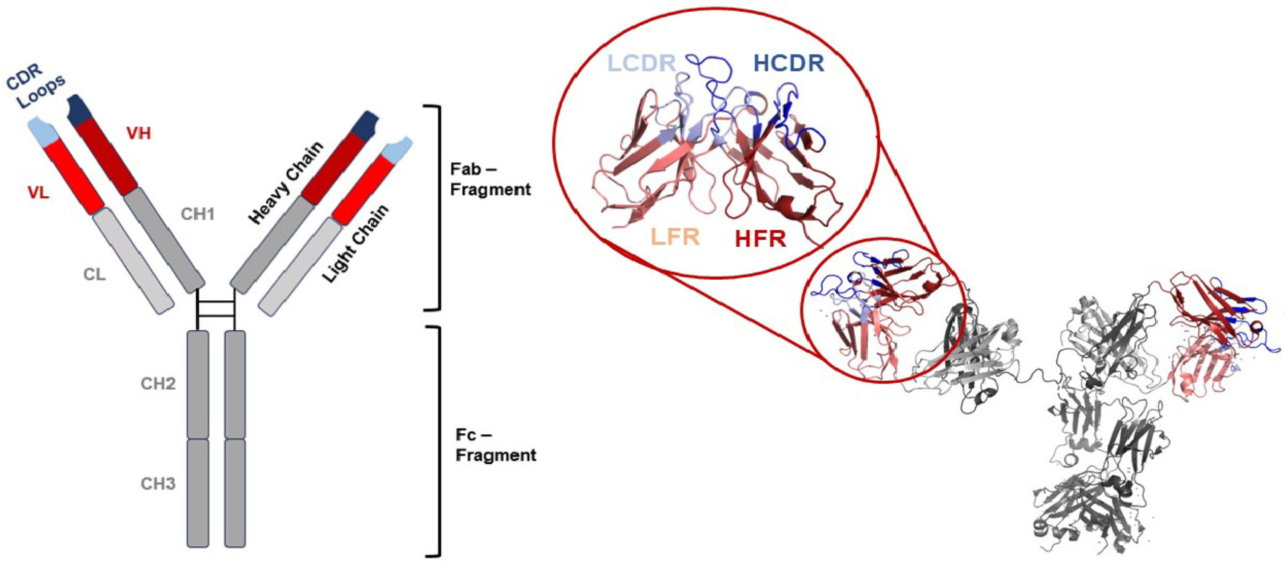
Figure 1: Overall Antibody Structure [17]

Therapeutic Importance of Antibody Binding
Over the last few decades, monoclonal antibodies (mAbs) have become a central component of modern biopharmaceuti- cals. They are engineered to bind specifically to defined molecular targets, allowing precise modulation of biological pathways. Since the approval of the first therapeutic antibody in 1986 (muromonab-CD3), the number of clinically approved mAbs has grown steadily, with applications spanning oncology, autoimmune disorders, and infectious diseases [19, 20]. Their success relies on the ability to design antibodies with high specificity and controlled effector functions, reducing off-target effects and enabling targeted interventions. Additionally, mAbs serve as the basis for advanced biologics, such as antibody–drug conjugates (ADCs) and bispecific antibodies [21].
A recent and impactful example is the deployment of monoclonal antibodies against SARS-CoV-2, the virus responsible for COVID-19. Antibodies such as bebtelovimab, tixagevimab, and cilgavimab received emergency use authorization for treatment and pre-exposure prophylaxis, particularly benefiting patients unable to mount adequate immune responses to vaccines. These cases demonstrate how antibody therapeutics can complement vaccines and small-molecule drugs in combating emerging pathogens [22, 23, 24]. Beyond traditional discovery, the integration of deep learning has catalyzed computational drug repurposing [25, 26, 27] and generative design [28, 29], enabling the rapid identification of neutralizing candidates from existing biologics libraries to keep pace with rapid viral evolution. Given their immense clinical and commercial significance, the development of high-throughput tools for predicting antibody–antigen binding affinity has become a critical pillar for rational drug design and pandemic preparedness.

Experimental Methods for Measuring Binding Affinity
Accurate quantification of antibody–antigen binding affinity is essential for characterizing immune interactions and developing therapeutic antibodies. Several experimental techniques have been established, each offering different levels of precision, throughput, and cost-effectiveness.

The Radioimmunoassay (RIA) is one of the earliest quantitative methods, using radiolabeled antigens or antibodies to detect and measure complex formation. While RIA provides high sensitivity, it requires radioactive materials, making it hazardous, expensive, and less favorable in modern laboratories [30, 31]. The Enzyme-Linked Immunosorbent Assay (ELISA) employs enzyme-linked antibodies that produce measurable colorimetric or fluorescent signals upon antigen binding. ELISA is well-suited for medium-throughput screening but may have limited sensitivity for very weak or transient interactions [32, 33].
Surface Plasmon Resonance (SPR) provides real-time, label-free measurement of molecular interactions, allowing determination of kinetic parameters in addition to overall affinity constants. Despite its precision, SPR requires specialized equipment and can be costly and low-throughput for large-scale screening [34]. Bio-Layer Interferometry (BLI) offers a more scalable alternative to SPR, though with reduced sensitivity for small molecules or low-affinity interactions [35].

Although these techniques yield accurate results, they are resource-intensive, time-consuming, and not easily scalable for high-throughput applications. The increasing availability of large immunological datasets has enabled computational approaches that predict binding affinity rapidly and at lower cost.

Computational Approaches for Antibody–Antigen Affinity Prediction

Computational methods provide a powerful alternative to experimental affinity determination, enabling the rapid screening of expansive molecular libraries. These approaches are broadly categorized into structure-based and sequence-based paradigms.

Structure-based methods rely on the three-dimensional (3D) coordinates of the antibody–antigen complex to estimate binding energy. Traditional tools such as RosettaAntibody, FoldX, and CSM-AB utilize physics-based force fields and geometric complementarity to model the energetic properties of the binding interface [36, 37]. While these methods offer high physical interpretability, they are inherently limited by the "structural bottleneck": the scarcity and high cost of obtaining high-resolution experimental structures via X-ray crystallography or Cryo-EM [17]. Although recent deep learning breakthroughs like AlphaFold 3 and Boltz-2 have significantly improved complex structure prediction, they still encounter difficulties in modeling the high flexibility of the CDR-H3 loop and often require substantial computational resources for large-scale affinity ranking [6, 38, 39].

Sequence-based methods circumvent structural requirements by predicting affinity directly from amino acid sequences. Early models primarily utilized hand-crafted physicochemical features (e.g., hydropathy, polarity) coupled with traditional machine learning. However, recent advancements in Protein Language Models (PLMs), such as ESM-2, ProtBERT, and Ablang, have revolutionized this field by providing high-dimensional, contextualized embeddings that implicitly encode evolutionary and biophysical information [10, 40, 41].

More recently, deep learning has shown superior performance by capturing complex, non-linear relationships. Models such as PIPR, RCNN-based frameworks, MVSF-AB, and DG-Affinity employ convolutional or recurrent architectures [42, 43], while pre-trained protein language models like ESM, ProtBERT, and Ablang provide rich embeddings encoding evolutionary and structural context [10, 41, 40]

DG-Affinity [44], a sequence-based deep learning framework designed to predict antibody antigen binding affinities, have demonstrated that utilizing PLMs like ConvNeXt architectures can achieve Pearson correlations exceeding 0.65 without any structural input [44]. The model leverages two specialized pretrained protein language models to capture domain-specific sequence representations: TAPE for antigens and AbLang for antibodies. Similarly, the AntiBinder
[45] framework employs bidirectional cross-attention to capture the intrinsic mechanisms of antigen–antibody interactions, highlighting the effectiveness of attention-based sequence modeling [45].

Another prominent example of recent sequence-only modeling is MVSF-AB [46], which addresses the lack of structural data through a multi-view learning strategy. MVSF-AB operates at two levels: Semantic Level where it utilizes ProteinBERT embeddings and CNNs to capture global biochemical semantics and Residue Level where it extracts physicochemical descriptors from the AAindex database, using matrix decomposition and Multi-Layer Perceptrons (MLPs) to learn binding-site relationships. While MVSF-AB [46] represents a significant

step forward in feature fusion, it relies on static residue-level descriptors and simple MLP architectures for local patterns.

Hybrid embedding strategies have emerged that combine general-purpose models like ESM-2 [10] with antibody- specific models like AntiBERTy given ESM-2 + AntiBERTy (Ranking) [47] . When deployed in a ranking setup, these dual-embedding models capture both global protein language patterns and specific paratope-epitope dependencies, outperforming traditional single-model baselines in prioritizing high-affinity binders [48].

MINT (Multimeric Interaction Transformer) [49] represents a new generation of PLMs specifically designed to model sets of interacting protein sequences. Unlike traditional PLMs that process sequences in isolation, MINT treats antibody and antigen as an interdependent pair. It has demonstrated state-of-the-art performance in zero-shot binding affinity ranking and mutational impact assessment across diverse PPI benchmarks [49].

To bridge the gap between biophysical rigor and sequence scalability, recent frameworks have adopted a hybrid approach. A prominent example is WALLE-Affinity [50], a Graph Neural Network (GNN) that integrates structural graph representations of antibody-antigen complexes with pre-trained protein language model (PLM) embeddings [50]. WALLE-Affinity (Regression) initially formulated to estimate real-valued binding scores, this model leverages GNNs to "absorb" structural inaccuracies and flexible domain dynamics while using PLM embeddings for biochemical context [51]. WALLE-Affinity (Ranking), more recently, the model has been reframed as a pairwise ranking framework within the AbRank benchmark. This version learns relative binding preferences rather than absolute values, significantly improving robustness to experimental noise and heterogeneous assay conditions [50].

The framework proposed in this research, DuaDeep-SeqAffinity, advances antibody-antigen affinity prediction by overcoming the limitations of current state-of-the-art models. While hybrid models like WALLE-Affinity rely on scarce 3D structural templates, and sequence-only models like MINT use standard Transformers that flatten feature representation, DuaDeep employs a novel dual-stream hybrid architecture. By running Transformer encoders and 1D CNNs in parallel, the framework explicitly separates the extraction of long-range global context from fine-grained local motifs. These multiscale features are then integrated through a specialized fusion module, providing a scalable, sequence-only solution that captures complex binding signatures without requiring structural data.

Methodology
Our proposed framework, named DuaDeep-SeqAffinity, is designed to predict antigen-antibody affinity scores directly from their raw amino acid sequences, circumventing the need for computationally expensive structural docking. This framework, conceptually illustrated in Figure 2, is structured as a sophisticated end-to-end deep learning pipeline. It comprises three main, interdependent stages:
- (1) Sequence Embedding using the powerful pre-trained ESM-2 protein language model,
- (2) Dual-Stream feature extraction network combining Transformers and Convolutional Neural Networks (CNNs) to capture both global and local interaction patterns for antibodies and antigens sequences separately
- (3) Interaction prediction head for affinity scoring.
The subsequent sections detail the architecture and function of each stage.

ESM-2 Based Sequence Embedding Module
The initial and fundamental step involves transforming raw amino acid sequences into high-dimensional, context-rich numerical representations. We leverage the ESM-2 (Evolutionary Scale Modeling 2) protein language model for this purpose. ESM-2, a Transformer-based model pre-trained on billions of protein sequences, has learned an implicit understanding of protein structure, function, and evolutionary relationships directly from sequence data.

Let the input antigen sequence be S_{A} = (a₁, a₂, . . . , a_{L}) and the antibody sequence be S_{B} = (b₁, b₂, . . . , b_{M} ), where
L and M are their respective lengths.
- Tokenization: Each amino acid in S_{A} and S_{B} is treated as a token.

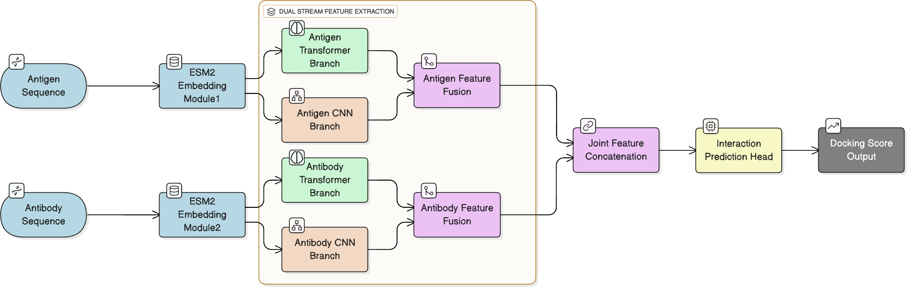
Figure 2: Dual-Stream Deep Learning Framework (DuaDeep: ESM-2 + Transformer + CNN) for Sequence-Only Antigen-Antibody Affinity Prediction

- Embedding: Each tokenized sequence is fed independently into a pre-trained ESM-2 model. ESM-2 processes these sequences and outputs a contextualized embedding vector for each amino acid residue.
  - For the antigen: E_{A} = (e_{a1}, e_{a2}, . . . , e_{aL}), where e_{ai} R^{D}E is the embedding for the i-th amino acid a of the antigen.
∈
  - For the antibody: E_{B} = (e_{b1}, e_{b2}, . . . , e_{bM} ), where e_{bj} R^{D}E is the embedding for the j-th amino acid
∈
b of the antibody.
Here, D_{E} is the dimensionality of the ESM-2 embeddings (D_{E} = 1280 for esm2_t33_650M_UR50D). These embeddings are crucial as they capture complex biophysical and functional information implicitly encoded in the protein sequences, acting as a rich numerical language for proteins.

Dual-Stream Feature Extraction Network: Transformer + CNN
This module is designed to extract complementary features from the ESM-2 embeddings of both the antigen and antibody, operating in :
- two parallel "streams": one stream for the antigen and another stream for the antibody, and
- two parallel "branches" : Transformer and CNN within each stream.
Let E_{X} denote the ESM-2 embeddings for a generic protein sequence, with E_{X} R^{L}X ×DE , where L_{X} is the length of sequence X and D_{E} is the embedding dimensionality.
∈

Transformer Branch
Each stream (antigen and antibody) feeds its ESM-2 embeddings into a dedicated Transformer encoder. Transformers are highly effective at capturing long-range dependencies and global contextual relationships within sequences, crucial for understanding how distant residues contribute to the overall protein conformation and potential binding sites.

The core of a Transformer encoder layer involves:
      - Multi-Head Self-Attention (MHSA): For an input sequence of embeddings E_{X} ∈ R^{L}X ×DE , we linearly project E_{X} into Query (Q), Key (K), and Value (V ) matrices for each of H attention heads: Q_{h} = E_{X}W ^{(h)},
Q
K_{h} = E_{X}W ^{(h)}, V_{h} = E_{X}W ^{(h)} where W ^{(h)}, W ^{(h)} ∈ R^{D}E ×Dk and W ^{(h)} ∈ R^{D}E ×Dv are learnable weight
K
V
Q
K
V

matrices for head h, with D_{k} = D_{v} = D_{E}/H.

The scaled dot-product attention for each head is calculated as:

Attention(Q_{h}, K_{h}, V_{h}) = softmax

Q K^{T}
V_{h}
h
h
√
D_{k}

The outputs from all heads are then concatenated and linearly transformed:
MHSA(E_{X} ) = Concat(head₁, . . . , head_{H} )W_{O}
where head_{h} = Attention(Q_{h}, K_{h}, V_{h}) and W_{O} ∈ R^{D}E ×DE .

      - Add and Normalize: The MHSA output is then added to the input and normalized (Layer Normalization):
X_{MHSA} = LayerNorm(E_{X} + MHSA(E_{X} ))
      - Position-wise Feed-Forward Network (FFN): A two-layer fully connected network applied independently to each position in the sequence:

FFN(x) = W₂.ReLU(W₁.x + b₁) + b₂
where W₁ R^{D}E ×Dff , b₁ R^{D}ff , W₂ R^{D}ff ×DE , b₂ R^{D}E , and D_{ff} is the hidden dimension of the FFN (typically 4D_{E}).
∈ ∈ ∈ ∈

Add and Normalize (again):
X_{out} = LayerNorm(X_{MHSA} + FFN(X_{MHSA})) Multiple such encoder layers are stacked.

Transformer Outputs:
        - Antigen Transformer Output: T_{A} ∈ R^{L×D}E
        - Antibody Transformer Output: T_{B} ∈ R^{M×D}E

CNN Branch
Parallel to the Transformer branch, each stream employs a 1D Convolutional Neural Network. CNNs are adept at identifying local sequence motifs and patterns, which are indicative of specific structural elements or binding hotspots.

For an input sequence of embeddings E_{X} ∈ R^{L}X ×DE :
      - 1D Convolutional Layers: A convolutional layer applies a filter (kernel) of a specific size across the sequence. Two sequential convolutional layers are applied:

F_{W} −1 D_{E} −1
Σ

O_{k,j} = RELU (
i=0
dΣ=0
W_{k,i,d} · E_{X} [j + i, d] + B_{k})

Where W_{k,i,d} are the learnable filter weights, F_{W} is the filter width (kernel size), B_{k} is the bias term, and
O_{k,j} is the output activation for filter k at position j.

The architecture consists of:
- First convolutional layer: 256 filters, kernel size 3, ReLU activation
- Second convolutional layer: 128 filters, kernel size 5, ReLU activation

      - Adaptive Average Pooling: After convolution, pooling layers are applied to downsample the feature maps and extract the most salient local features into a fixed-size vector. P_{k} = averagej (O_{k,j}) (Global Average Pooling)

CNN Outputs:
        - Antigen CNN Output: C_{A} ∈ R^{D}CNN (a single vector)
        - Antibody CNN Output: C_{B} ∈ R^{D}CNN (a single vector)
Where, D_{CNN} = 128 (number of filters in the final convolutional layer)

Feature Fusion
The outputs from the Transformer and CNN branches for each protein must be combined effectively.
- Transformer Output Condensation: Since T_{A} and T_{B} are sequences of embeddings, we first condense them into fixed-size vectors. A Global Average Pooling layer is suitable for this, providing an average representation of all contextualized residue embeddings.
T¯A = GlobalAveragePooling(T_{A}) ∈ R^{D}E
T¯B = GlobalAveragePooling(T_{B}) ∈ R^{D}E
- Intra-Protein Feature Concatenation: The condensed Transformer output is concatenated with the CNN output for each respective protein.
F_{A} = [T¯A; C_{A}] ∈ R^{D}E +DCNN
F_{B} = [T¯B ; C_{B}] ∈ R^{D}E +DCNN
- Inter-Protein Feature Concatenation: Finally, to capture the potential interactions between the antigen and antibody, their fused feature vectors are concatenated.
FAB = [FA; FB ] ∈ R2×(DE +DCNN )
This vector F_{AB} serves as the comprehensive input to the final prediction head.

Interaction Prediction Head
This module is responsible for regressing the final docking score from the rich, fused feature vector F_{AB}. It consists of a series of fully connected (dense) layers. A dense layer performs a linear transformation followed by an element-wise non-linear activation function. For an input vector of features x ∈ R^{N} to a dense layer with K output neurons:
y = g(xW + b)
where W R^{N×K} is the weight matrix, b R^{K} is the bias vector, and g( ) is the activation function (ReLU for hidden layers).
∈ ∈ ·

- Stacked Dense Layers: A typical setup would involve several dense layers with decreasing neuron counts.
- Output Layer: The final layer will have a single neuron with a linear activation function to output the continuous docking score.

ˆ T
S = (y
last
Wout) + bout

where y_{last} ∈ R^{D}hidden , W_{out} ∈ R^{D}hidden , b_{out} ∈ R and Sˆ ∈ R (scalar) is the predicted docking score.
The model is trained using a regression loss function, Mean Squared Error (MSE), to minimize the difference between the predicted score Sˆ and the true experimental docking score S_{true}

L = MSE(Sˆ, S

true

1
) =
Nsamples

Nsamples i=1
Σ

(Sˆi − S

true,i)2

Modeling Variations:
To validate the idea of Dual-Stream architecture, we propose training and evaluating two distinct model variations. These models are built upon the foundational ESM-2 embedding and share the same final prediction head, differing only in their core feature extraction networks. This comparative analysis will isolate the contribution of global context (Transformer) versus local motifs (CNN) in predicting antigen-antibody affinity.

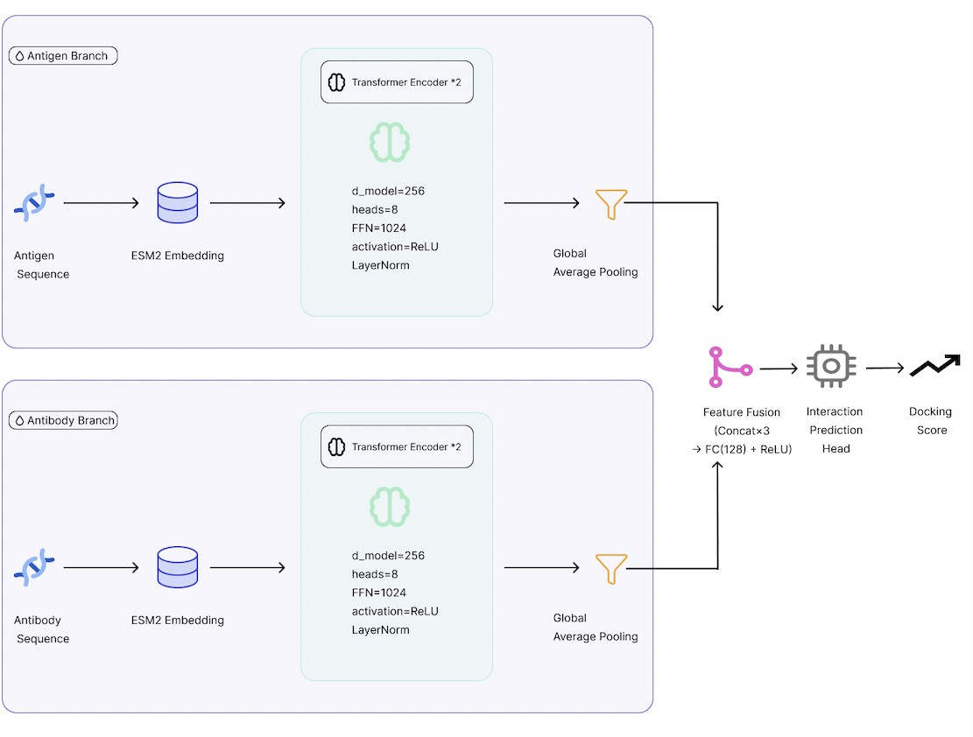
Figure 3: Transformer-based Architecture (ESM-T: ESM-2 + Transformer) for Antibody–Antigen Feature Extraction and Affinity Prediction.
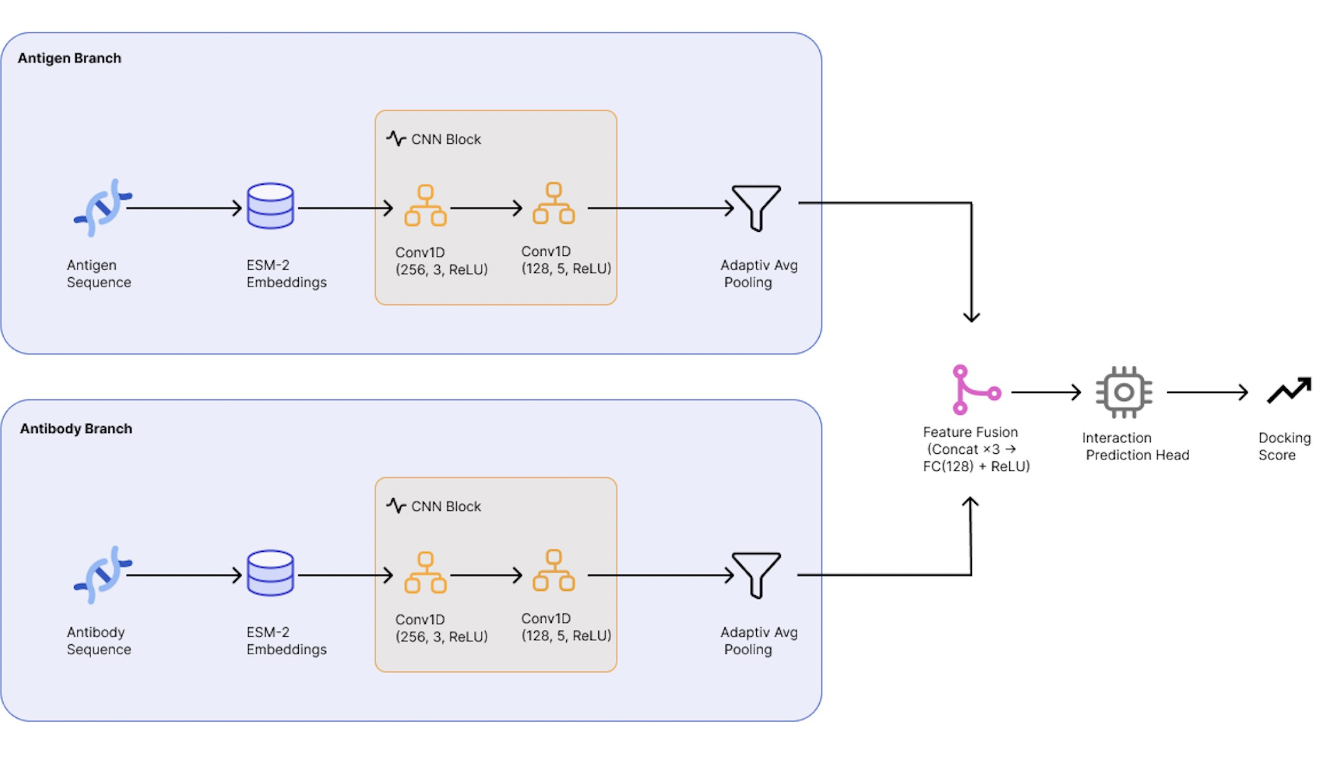

Figure 4: CNN-based Architecture (ESM-C: ESM-2 + CNN) for Antibody–Antigen Feature Extraction and Affinity Prediction.

Model ESM + Transformer (ESM-T)
The ESM-Tmodel is designed to capture long-range contextual dependencies within each protein sequence using the powerful attention mechanism. This model exclusively leverages the global sequence representation derived from ESM-2 and refined by the Transformer. The ESM-T is represented in Figure 3 and is performing as follow :

- Raw amino acid sequences of the Antigen (X_{A}) and Antibody (X_{B}) are passed through the pre-trained ESM-2 model to generate contextualized sequence embeddings (E_{A} and E_{B})
- E_{A} and E_{B} are fed into separate, stacked Transformer Encoder blocks (identical structures). These blocks use Multi-Head Self-Attention (MHSA) and Position-wise Feed-Forward Networks (FFN) to capture global relationships between residues.
T_{A} = Transformer(E_{A}), T_{B} = Transformer(E_{B})
- The two condensed feature vectors (T¯A, T¯B ) are concatenated, F_{AB} = [T¯A; T¯B ], and regressed to the final affinity score (Sˆ) via the Interaction Prediction Head (MLP).

Model ESM + CNN (ESM-C)
The ESM-C model focuses exclusively on identifying local sequence motifs and binding hotspots by utilizing Convo- lutional Neural Networks (CNNs) to process the ESM-2 embeddings. The ESM-T is represented in Figure 4 and is performing as follow :
- Generates the contextualized sequence embeddings (E_{A} and E_{B}) with ESM-2.
- E_{A} and E_{B} are fed into separate, stacked 1D CNN branches (identical structure). The 1D convolutional layers use filters to slide across the sequence, identifying local patterns across the D_{E} embedding channels.
C_{A,seq} = CNN(E_{A}), C_{B,seq} = CNN(E_{B})
- The two condensed CNN feature vectors (C_{A}, C_{B}) are concatenated, F_{AB} = [C_{A}; C_{B}], and passed to the Interaction Prediction Head (MLP).

Results and Discussion

Dataset
The experiments were conducted on the publicly available AbRank dataset [52], which provides experimentally validated antigen–antibody pairs along with their corresponding binding affinities (expressed as K_{d} values in nM). Each record includes the amino-acid sequences of the antigen and the antibody heavy and light chains, enabling sequence-level modeling of antigen–antibody interactions.

- Preprocessing:

Raw sequences were cleaned to retain only standard amino-acid characters (A–Y). Nonstandard or missing residues were replaced with the placeholder token “X”. Entries with missing or invalid affinity values were removed, and affinity values were filtered to retain samples within a biologically meaningful range (10⁻³ < K_{d} < 10⁹ nM). The cleaned K_{d} values were converted into negative logarithmic form as:
pK_{d} = 9 − log10(K_{d})
which produces a scale positively correlated with binding strength. To stabilize training, pK_{d} values were standardized using a z-score (StandardScaler) normalization.

Data splitting: The dataset was randomly divided into 80% training, 10% validation, and 10% testing subsets This split maintains non-overlapping antigen and antibody sequences between sets to fairly evaluate generalization on unseen pairs.

Tokenization: Sequences were tokenized using the ESM-2 (facebook/esm2_t12_35M_UR50D) tokenizer with a maximum input length of 512 residues. Each sequence (antigen, heavy chain, and light chain) was independently embedded using frozen ESM-2 representations before being passed to the dual-stream model.

Overall, this preprocessing pipeline ensures consistent and biologically sound input representations while aligning with the AbRank data preparation protocols, allowing for a fair comparison with existing models such as WALLE-Affinity.

Architecture RMSE MAE R2 Pearson Spearman
ESM-C: ESM + CNN 0.7733 0.5722 0.397 0.636 0.614
ESM-T: ESM + Transformer 0.7985 0.5822 0.357 0.625 0.603

DuaDeep: ESM + Transformer + CNN 0.7373 0.5116 0.460 0.688 0.680
Table 1: Performance comparison of different model architectures for affinity score prediction. The table reports regression metrics (RMSE, MAE, and R²) and correlation coefficients (Pearson and Spearman) for the ESM-C, ESM-T, and the best dual-stream DuaDeep models.

Model Performance
To assess the predictive power of the proposed DuaDeep-SeqAffinity framework, we evaluated three architectural variants built upon ESM-2 sequence embeddings:
- (1) DuaDeep : ESM + Transformer + CNN
- (2) ESM-T: ESM + Transformer
- (3) ESM-C: ESM + CNN
All models were trained under identical settings for a fair comparison.

As summarized in Table 1, the proposed Dual-Stream hybrid architecture (ESM + Transformer + CNN) achieved the best overall performance, with an RMSE of 0.7373, MAE of 0.5116, and the highest coefficient of determination R² = 0.460. The model also reached the highest correlation scores (Pearson = 0.688, Spearman = 0.680). Compared to the to the uni-stream CNN-only (ESM-C) and Transformer-only (ESM-T) baselines, the hybrid model reduces RMSE by more than 4.6. The consistent increase in correlation metrics further suggests that the dual-stream network captures meaningful physicochemical dependencies that govern antigen–antibody interactions. The obtained results demonstrating that the synergistic integration of global contextual embeddings and local motif extraction captures complex binding signatures more effectively than either architectural component in isolation. These experimentations confirm that integrating both global and local feature extractors provides complementary advantages. Their joint fusion enables the model to represent both structural context and motif-level specificity more effectively than single-stream architectures.

The evolution of training and validation RMSE across epochs for the three architectures is depicted in Figures 5–7. All models exhibit stable convergence, but the rate and final plateau differ notably between variants. The ESM + CNN baseline (Figure 5) shows a gradual decrease in RMSE with a persistent gap between training and validation curves, indicating limited generalization due to its focus on local features only. The ESM + Transformer model (Figure 6) achieves faster early convergence and a reduced gap, confirming the benefit of global contextual modeling through self-attention mechanisms. Finally, the ESM + Transformer + CNN (Dual-Stream) architecture (Figure 7), demonstrates the most consistent convergence and lowest validation RMSE, reaching 0.7338 at Epoch 6. This smooth and overlapping behavior observed in these initial epochs suggests efficient learning dynamics and strong regularization, supporting the hybrid model’s superior generalization observed in Table 1.

To further evaluate the quality of the learned representations, Figure 8 presents a side-by-side comparison of the best validation metrics achieved by each architecture. Consistent with the RMSE trends, the ESM + Transformer + CNN (Dual-Stream) model demonstrates superior predictive capability across all metrics. Specifically, the hybrid architecture achieves an R² score of 0.454 and a Pearson correlation of 0.681, significantly surpassing the baselines. Interestingly, the CNN baseline (max R² 0.39, Pearson 0.64) performs slightly better than the Transformer on these regression metrics, suggesting that local structural features are particularly informative for this specific task. Ultimately, the dual-stream approach yields the highest scores across all categories (including a Spearman correlation of 0.672 ), confirming that combining local feature extraction with global contextual modeling results in the most robust and generalized predictor.
≈ ≈

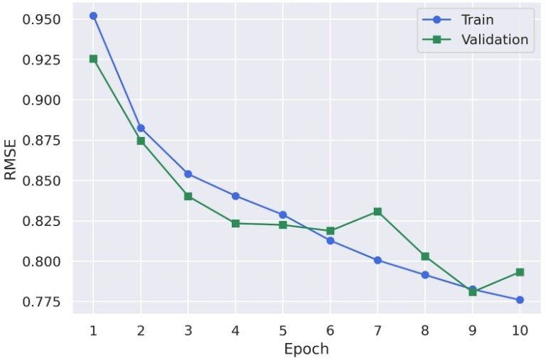
Figure 5: Training and validation learning curves for the ESM-C: ESM + CNN architecture for Affinity prediction.
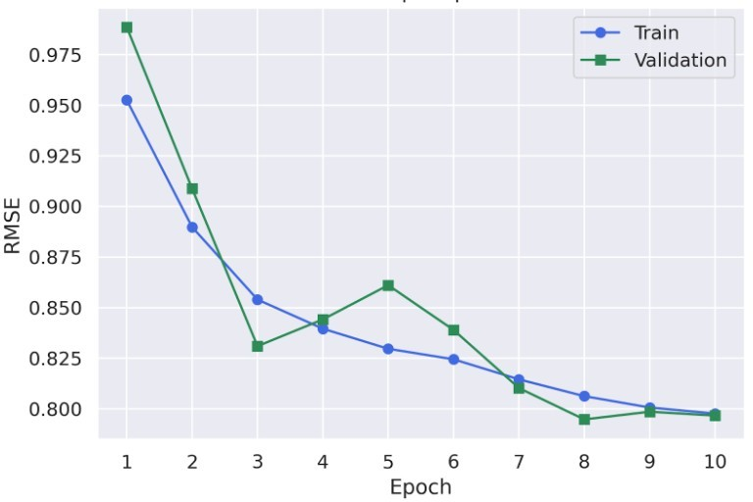
Figure 6: Training and validation learning curves for the ESM-T: ESM + Transformer architecture for Affinity prediction.
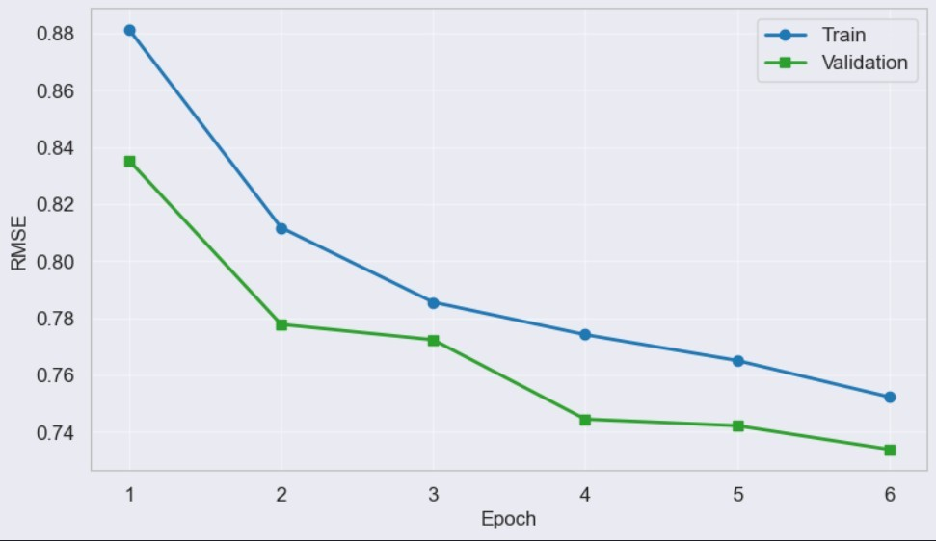
Figure 7: Training and validation learning curves for the DuaDeep: ESM + Transformer + CNN architecture for Affinity prediction.

State of the Art Comparison :
To position DuaDeep-SeqAffinity within the broader landscape of antibody–antigen affinity prediction, we compared its performance against several recent state-of-the-art models, including both structure-aware and sequence-only frameworks. The reference benchmarks were drawn from the AbRank (WALLE-Affinity) study [50], the DG-Affinity model [54], and the MVSF-AB model [55]. Tables 2 and 3 summarize these models, their architectural categories, and report key performance metrics.

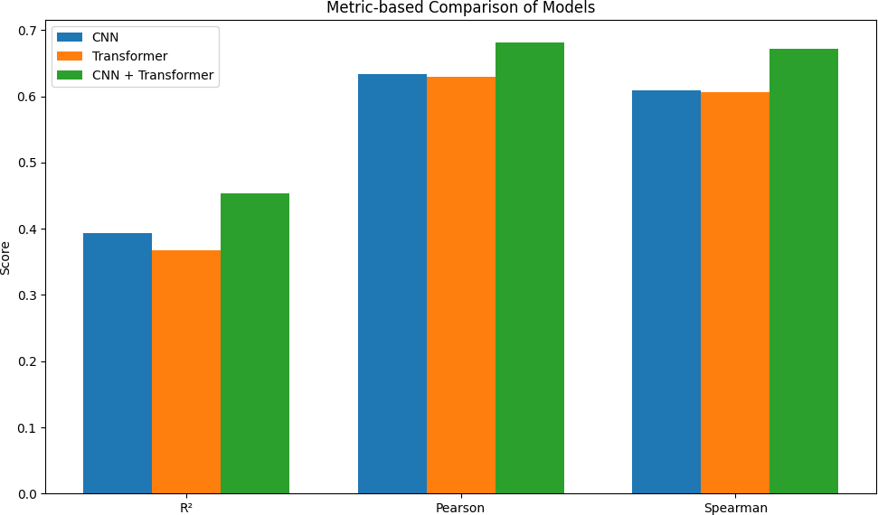

Figure 8: Comparative validation performance of Uni-Stream ESM-T (Transformer), ESM-C (CNN) models and Dual-Stream proposed architectures DuaDeep (CNN + Transformer) across primary evaluation metrics (R², Pearson correlation, and Spearman correlation).

Model | Architecture / Input Type | Pearson | R2 | RMSE
DG-Affinity (independent test) [44] | Sequence-only (ConvNeXt) | 0.6556 | - | -
MVSF-AB (expanded benchmark) [46] | Sequence-only (multi-view CNN + MLP) | - | 0.467 | 1.447
ESM-C (ESM + CNN) | Sequence-only (our) | 0.636 | 0.397 | 0.773
ESM-T (ESM + Transformer) | Sequence-only (our) | 0.625 | 0.357 | 0.798
DuaDeep (ESM + Transformer + CNN) | Sequence-only (our) | 0.688 | 0.460 | 0.737
Table 2: Performance comparison of our proposed models against state-of-the-art (SOTA) methods for antigen-antibody affinity prediction. Performance is evaluated using Pearson correlation, the coefficient of determination (R²), and Root Mean Square Error (RMSE) reported as stated in their respective publications, across various architectures and input types. Our best proposed DuaDeep-SeqAffinity architecture achieves a superior values for all metrics, outperforming current SOTA.

Model | Architecture / Input Type | AUC
WALLE-Affinity (Ranking) [50] | Structure + sequence | 0.866
WALLE-Affinity (Regression) [50] | Structure + sequence | 0.833
ESM-2 + AntiBERTy (ranking) [53] | Sequence-only | 0.761
Mint (ranking) [49] | Sequence-only | 0.775
ESM-C (ESM + CNN) | Sequence-only (our) | 0.854
ESM-T (ESM + Transformer) | Sequence-only (our) | 0.852
DuaDeep (ESM + Transformer + CNN) | Sequence-only (our) | 0.890
Table 3: Performance comparison of proposed models against state-of-the-art (SOTA) methods for antigen-antibody interaction prediction. The evaluation highlights the Area Under the Curve (AUC), reported as stated in their respective publications, across various architectures and input types. All our models ESM-T, ESM-C and our best proposed DuaDeep-SeqAffinity architecture achieve a superior AUC, outperforming current SOTA.

As demonstrated in Table 2, our model achieves superior predictive regression accuracy, reaching a Pearson correlation of 0.688, which significantly outperforms the previous sequence-based SOTA, DG-Affinity (0.6556). Furthermore, while MVSF-AB demonstrates a comparable R² of 0.467, it suffers from a drastically higher error rate (RMSE = 1.447), whereas DuaDeep maintains a much more precise RMSE of 0.737.

Table 3 shows that DuaDeep-SeqAffinity establishes a new performance ceiling with an AUC of 0.890. Most notably, this sequence-only approach surpasses WALLE-Affinity (Ranking), which utilizes explicit 3D structural information (AUC = 0.866). This performance gap is particularly significant: it proves that the high-capacity embeddings from ESM-2, when processed through our dual-stream architecture, can extract interaction signatures that are more informative than those derived from potentially noisy or rigid structural templates. Despite differing metrics and evaluation protocols, these results collectively illustrate that sequence-only models are rapidly approaching, and in some cases exceeding, the performance of hybrid sequence–structure frameworks.

Overall, these findings validate the benefit of multi-branch feature extraction for sequence-based affinity prediction. By outperforming ranking models like Mint (AUC = 0.775) and ESM-2 + AntiBERTy (AUC = 0.761) by a wide margin (Table 3), DuaDeep-SeqAffinity demonstrates that sophisticated architectural fusion is as critical as the choice of pre-trained embeddings. By eliminating the reliance on 3D structural data without sacrificing precision, this framework provides a highly scalable solution for the high-throughput screening of vast antibody libraries, effectively bypassing the most significant bottleneck in the therapeutic discovery pipeline.

Conclusion
This research introduced DuaDeep-SeqAffinity, a sophisticated dual-stream deep learning framework designed to predict antigen–antibody binding affinity directly from primary amino acid sequences. By leveraging high-capacity ESM-2 embeddings within a hybrid architecture of Transformer encoders and 1D Convolutional Neural Networks (CNNs), the model effectively bridges the gap between sequence scalability and structural precision. Our architectural design enables the simultaneous capture of long-range global contextual dependencies and fine-grained local interaction motifs, features previously thought to require explicit 3D structural modeling.

Experimental evaluations demonstrate that the synergistic integration of these streams achieves state-of-the-art perfor- mance, yielding an RMSE of 0.7373, an R² of 0.460, and a superior AUC of 0.890. Notably, DuaDeep-SeqAffinity surpasses current sequence-based benchmarks and, crucially, outperforms the structure-aware WALLE-Affinity framework (AUC = 0.866). These results provide compelling evidence that robust pre-trained embeddings, when paired with multiscale feature extraction, can decode the complex physicochemical signatures of binding interfaces without the computational burden of 3D template generation.

DuaDeep-SeqAffinity offers a fast, scalable, and structure-independent solution that is uniquely suited for the high- throughput demands of modern antibody discovery and rational vaccine design. By circumventing the "structural bottleneck," this framework significantly reduces the pre-clinical computational overhead while maintaining high predictive fidelity. Future research will explore the integration of cross-attention mechanisms and ranking-based loss functions to further refine interaction modeling. Additionally, the development of interpretable residue-level interaction maps will be prioritized to enhance model explainability, ultimately providing researchers with actionable insights into the molecular basis of immune recognition.

Data availability statements
The complete dataset used in this study is publicly available at
https://www.kaggle.com/datasets/aurlienplissier/abrank.

References
- Ruei-Min Lu, Yu-Chyi Hwang, I-Ju Liu, Chi-Chiu Lee, Han-Zen Tsai, Hsin-Jung Li, and Han-Chung Wu. Development of therapeutic antibodies for the treatment of diseases. Journal of biomedical science, 27(1):1, 2020.
- Tao Tang, Xiaocai Zhang, Yuansheng Liu, Hui Peng, Binshuang Zheng, Yanlin Yin, and Xiangxiang Zeng. Machine learning on protein–protein interaction prediction: models, challenges and trends. Briefings in Bioinfor- matics, 24(2):bbad076, 2023.
- Dima Kozakov, David R Hall, Bing Xia, Kathryn A Porter, Dzmitry Padhorny, Christine Yueh, Dmitri Beglov, and Sandor Vajda. The cluspro web server for protein–protein docking. Nature protocols, 12(2):255–278, 2017.
- Francis Gaudreault, Traian Sulea, and Christopher R Corbeil. Ai-augmented physics-based docking for antibody- antigen complex prediction. Bioinformatics, 41(4):btaf129, 2025.
- Helen M Berman, John Westbrook, Zukang Feng, Gary Gilliland, Talapady N Bhat, Helge Weissig, Ilya N Shindyalov, and Philip E Bourne. The protein data bank. Nucleic acids research, 28(1):235–242, 2000.
- Josh Abramson, Jonas Adler, Jack Dunger, Richard Evans, Tim Green, Alexander Pritzel, Olaf Ronneberger, Lindsay Willmore, Andrew J Ballard, Joshua Bambrick, et al. Accurate structure prediction of biomolecular interactions with alphafold 3. Nature, 630(8016):493–500, 2024.
- Fatima N Hitawala and Jeffrey J Gray. What does alphafold3 learn about antibody and nanobody docking, and what remains unsolved? In MAbs, volume 17, page 2545601. Taylor & Francis, 2025.

- Xiangzhe Kong, Wenbing Huang, and Yang Liu. Conditional antibody design as 3d equivariant graph translation.
arXiv preprint arXiv:2208.06073, 2022.
- Cheng Tan, Yijie Zhang, Zhangyang Gao, Yufei Huang, Haitao Lin, Lirong Wu, Fandi Wu, Mathieu Blanchette, and Stan Z Li. dyab: Flow matching for flexible antibody design with alphafold-driven pre-binding antigen. In Proceedings of the AAAI Conference on Artificial Intelligence, volume 39, pages 782–790, 2025.
- Zeming Lin, Halil Akin, Roshan Rao, Brian Hie, Zhongkai Zhu, Wenting Lu, Nikita Smetanin, Robert Verkuil, Ori Kabeli, Yaniv Shmueli, et al. Evolutionary-scale prediction of atomic-level protein structure with a language model. Science, 379(6637):1123–1130, 2023.
- Qianying Li, Yanmin Zhao, Mahendra D Chordia, Xiuming Xia, Bo Zhang, and Heping Zheng. Enhanced prediction of antigen and antibody binding interface using esm-2 and bi-lstm. Human Immunology, 86(3):111304, 2025.
- Chen Liu, Mingchen Li, Yang Tan, Wenrui Gou, Guisheng Fan, and Bingxin Zhou. Sequence-only prediction of binding affinity changes: a robust and interpretable model for antibody engineering. Bioinformatics, 41(8):btaf446, 2025.
- Ruofan Jin, Qing Ye, Jike Wang, Zheng Cao, Dejun Jiang, Tianyue Wang, Yu Kang, Wanting Xu, Chang-Yu Hsieh, and Tingjun Hou. Attabseq: an attention-based deep learning prediction method for antigen–antibody binding affinity changes based on protein sequences. Briefings in Bioinformatics, 25(4):bbae304, 2024.
- Mark L Chiu, Dennis R Goulet, Alexey Teplyakov, and Gary L Gilliland. Antibody structure and function: the basis for engineering therapeutics. Antibodies, 8(4):55, 2019.
- S. C. Oostindie, G. A. Lazar, J. Schuurman, and P. W. H. I. Parren. Avidity in antibody effector functions and biotherapeutic drug design. Nature Reviews Drug Discovery, 21(10):715–735, 2022.
- E. A. Padlan. Structural basis for the specificity of antibody–antigen reactions and structural mechanisms for the diversification of antigen-binding specificities. Quarterly Reviews of Biophysics, 10(1):35–65, 1977.
- Zirui Zhu, Katherine S Olson, and Thomas J Magliery. 50 years of antibody numbering schemes: a statistical and structural evaluation reveals key differences and limitations. Antibodies, 13(4):99, 2024.
- Valerie H Odegard and David G Schatz. Targeting of somatic hypermutation. Nature Reviews Immunology, 6(8):573–583, 2006.
- S. Singh, N. K. Tank, P. Dwiwedi, J. Charan, R. Kaur, P. Sidhu, and V. K. Chugh. Monoclonal antibodies: a review. Current Clinical Pharmacology, 13(2):85–99, 2018.
- V. Bayer. An overview of monoclonal antibodies. In Seminars in Oncology Nursing, volume 35, page 150927. WB Saunders, 2019.
- Y. Le Basle, P. Chennell, N. Tokhadze, A. Astier, and V. Sautou. Physicochemical stability of monoclonal antibodies: a review. Journal of Pharmaceutical Sciences, 109(1):169–190, 2020.
- K. Widyasari and J. Kim. A review of the currently available antibody therapy for the treatment of coronavirus disease 2019 (covid-19). Antibodies, 12(1):5, 2023.
- Y. C. Hwang, R. M. Lu, S. C. Su, P. Y. Chiang, S. H. Ko, F. Y. Ke, and H. C. Wu. Monoclonal antibodies for covid-19 therapy and sars-cov-2 detection. Journal of Biomedical Science, 29(1):1, 2022.
- P. C. Taylor, A. C. Adams, M. M. Hufford, I. De La Torre, K. Winthrop, and R. L. Gottlieb. Neutralizing monoclonal antibodies for treatment of covid-19. Nature Reviews Immunology, 21(6):382–393, 2021.
- Sweta Mohanty, Md Harun Ai Rashid, Mayank Mridul, Chandana Mohanty, and Swati Swayamsiddha. Application of artificial intelligence in covid-19 drug repurposing. Diabetes & Metabolic Syndrome: Clinical Research & Reviews, 14(5):1027–1031, 2020.
- Yadi Zhou, Fei Wang, Jian Tang, Ruth Nussinov, and Feixiong Cheng. Artificial intelligence in covid-19 drug repurposing. The Lancet Digital Health, 2(12):e667–e676, 2020.
- Aicha Boutorh, Kaouter Marref, and Naamat Ellah Dehiri. Graph representation learning for covid-19 drug repurposing. In International conference on computing systems and applications, pages 61–72. Springer, 2022.
- Ewen Callaway. How generative ai is building better antibodies. Nature, 617(7960):235–235, 2023.
- Liyun Huo, Tian Tian, Yanqin Xu, Qin Qin, Xinyi Jiang, and Qiang Huang. Deep generative design of neutralizing nanobodies against sars-cov-2 variants. bioRxiv, pages 2024–10, 2024.
- E. Block. An overview of radioimmunoassay testing and. In New Developments in Immunoassays: International Conference, Düsseldorf, November 1977, and Chicago, Ill., December 1977: Proceedings, volume 26, page 1. Karger Medical and Scientific Publishers, 1979.

- R. P. Vallejo and C. D. Ercegovich. Radioimmunoassay (ria). In Trace Organic Analysis: A New Frontier in Analytical Chemistry, volume 519, page 333. US Department of Commerce, National Bureau of Standards, 1979.
- Manzoor Ahmad Mir. Immunoglobulins, Magic Bullets and Therapeutic Antibodies. Nova Science Publishers, Incorporated, 2019.
- M. S. Tabatabaei and M. Ahmed. Enzyme-linked immunosorbent assay (elisa). In Cancer cell biology: Methods and protocols, pages 115–134. Springer US, New York, NY, 2022.
- R. P. Sparks, J. L. Jenkins, and R. Fratti. Use of surface plasmon resonance (spr) to determine binding affinities and kinetic parameters between components important in fusion machinery. In SNAREs: Methods and Protocols, pages 199–210. Springer New York, New York, NY, 2018.
- K. Rhea. Determining the binding kinetics of peptide macrocycles using bio-layer interferometry (bli). In Peptide Macrocycles: Methods and Protocols, pages 355–372. Springer US, New York, NY, 2021.
- Brian D Weitzner, Jeliazko R Jeliazkov, Sergey Lyskov, Nicholas Marze, Daisuke Kuroda, Rahel Frick, Jared Adolf-Bryfogle, Naireeta Biswas, Roland L Dunbrack Jr, and Jeffrey J Gray. Modeling and docking of antibody structures with rosetta. Nature protocols, 12(2):401–416, 2017.
- Yoochan Myung, Douglas EV Pires, and David B Ascher. Csm-ab: graph-based antibody–antigen binding affinity prediction and docking scoring function. Bioinformatics, 38(4):1141–1143, 2022.
- Saro Passaro, Gabriele Corso, Jeremy Wohlwend, Mateo Reveiz, Stephan Thaler, Vignesh Ram Somnath, Noah Getz, Tally Portnoi, Julien Roy, Hannes Stark, et al. Boltz-2: Towards accurate and efficient binding affinity prediction. BioRxiv, 2025.
- Jeffrey A Ruffolo, Lee-Shin Chu, Sai Pooja Mahajan, and Jeffrey J Gray. Fast, accurate antibody structure prediction from deep learning on massive set of natural antibodies. Nature communications, 14(1):2389, 2023.
- Tobias H Olsen, Iain H Moal, and Charlotte M Deane. Ablang: an antibody language model for completing antibody sequences. Bioinformatics Advances, 2(1):vbac046, 2022.
- Ahmed Elnaggar, Michael Heinzinger, Christian Dallago, Ghalia Rehawi, Yu Wang, Llion Jones, Tom Gibbs, Tamas Feher, Christoph Angerer, Martin Steinegger, et al. Prottrans: Toward understanding the language of life through self-supervised learning. IEEE transactions on pattern analysis and machine intelligence, 44(10):7112– 7127, 2021.
- Muhao Chen, Chelsea J-T Ju, Guangyu Zhou, Xuelu Chen, Tianran Zhang, Kai-Wei Chang, Carlo Zaniolo, and Wei Wang. Multifaceted protein–protein interaction prediction based on siamese residual rcnn. Bioinformatics, 35(14):i305–i314, 2019.
- Minhyeok Lee. Recent advances in deep learning for protein-protein interaction analysis: A comprehensive review.
Molecules, 28(13):5169, 2023.
- Ye Yuan, Qushuo Chen, Jun Mao, Guipeng Li, and Xiaoyong Pan. Dg-affinity: predicting antigen–antibody affinity with language models from sequences. BMC bioinformatics, 24(1):430, 2023.
- Kaiwen Zhang, Yuhao Tao, and Fei Wang. Antibinder: utilizing bidirectional attention and hybrid encoding for precise antibody–antigen interaction prediction. Briefings in Bioinformatics, 26(1), 2024.
- Minghui Li, Yao Shi, Shengqing Hu, Shengshan Hu, Peijin Guo, Wei Wan, Leo Yu Zhang, Shirui Pan, Jizhou Li, Lichao Sun, et al. Mvsf-ab: accurate antibody–antigen binding affinity prediction via multi-view sequence feature learning. Bioinformatics, 41(5):btae579, 2025.
- Jeffrey A Ruffolo, Jeremias Sulam, and Jeffrey J Gray. Antibody structure prediction using interpretable deep learning. Patterns, 3(2), 2022.
- Meng Wang, Jonathan Patsenker, Henry Li, Yuval Kluger, and Steven H Kleinstein. Supervised fine-tuning of pre-trained antibody language models improves antigen specificity prediction. PLOS Computational Biology, 21(3):e1012153, 2025.
- Varun Ullanat, Bowen Jing, Samuel Sledzieski, and Bonnie Berger. Learning the language of protein-protein interactions. bioRxiv, 2025.
- Chunan Liu, Aurelien Pelissier, Yanjun Shao, Lilian Denzler, Andrew CR Martin, Brooks Paige, and María Ro- dríguez Martínez. Abrank: A benchmark dataset and metric-learning framework for antibody-antigen affinity ranking. arXiv preprint arXiv:2506.17857, 2025.
- ChuNan Liu, Lilian Denzler, Yihong Chen, Andrew Martin, and Brooks Paige. Asep: Benchmarking deep learning methods for antibody-specific epitope prediction. Advances in Neural Information Processing Systems, 37:11700–11734, 2024.

- Aurélien Pélissier. AbRank: Antibody affinity ranking. https://www.kaggle.com/datasets/ aurlienplissier/abrank, 2025. Accessed: 2025-12-25.
- Jeffrey A Ruffolo, Jeffrey J Gray, and Jeremias Sulam. Deciphering antibody affinity maturation with language models and weakly supervised learning. arXiv preprint arXiv:2112.07782, 2021.
- Z. Li, S. Li, Y. Zhang, and Y. Yang. Dg-affinity: predicting antigen–antibody affinity with language models from sequences. BMC Bioinformatics, 24(1):1–15, 2023.
- Minghui Li et al. Mvsf-ab: accurate antibody–antigen binding affinity prediction via multi-view sequence feature learning. Bioinformatics, 40(Supplement_1):i345–i353, 2024.

